|  |  |  |  |
| --- | --- | --- | --- |
|  |  | **Activity Guide - Encoding Color Images** | logo.png |

**Objectives:**

* Practice with the color pixelation tool.
* Use the Pixelation Widget to recreate specific colors.
* Recreate simple color images and describe the difference when using 6 or 12 bits per pixel.
* Encode colors with hex.

**Directions:**

**Go to Code Studio - Find this lesson on Code Studio**

The tasks below follow the guided sequence in Code Studio which has tutorial videos followed by specific tasks. The purpose of this activity is only to become familiar with the color pixelation tool, and to practice a little bit, in order to be comfortable enough to start the **favicon assignment.**

## Step 1: 3-bit color

**Tutorial Video:** How to use the pixelation widget to control color.

**Task 1:** Fill in the last two pixels with the missing colors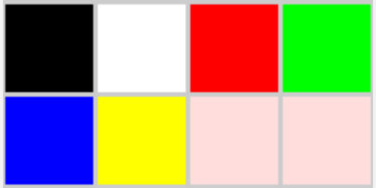

Problem: fill in the last two pixels.

Optional Practice: change the pixel data so that the blue and yellow pixels exchange locations in the image. If you mess up, you can always re-copy-paste the bits from this example.

## Step 2: 6-bit color

**Tutorial Video:** more bits per pixel for more colors

**Task 2:** Experiment with 6-bit color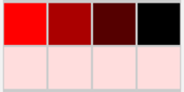

Set bits/pixel to 6 and experiment with each of the R, G, and B values. At 6 bits/pixel, it means each color channel has 2 bits assigned to it, so there are 4 possible shades of each of R, G, and B. To start you are presented with the image at right.

## Step 3: 12-bit color and hex

**Tutorial Video:** Using hex to type bits more quickly

**Task 3:** Experiment with Hex

**Make a 4x4 image with *bits-per-pixel set to 12* and the tool into *hexadecimal mode.***

NOTE: Using 12-bits-per-pixel (4096 colors!) is convenient because 12 bits maps to exactly 3 hex digits, one digit each for RGB. For example, to make a teal color (shown right) whose 12-bit value is: 001110101011 We can represent a 12-bit color in hex much more easily as hex: **3AB**. Here is the breakdown:

|  |  |  |  |
| --- | --- | --- | --- |
|  | R | G | B |
| binary | 0011 | 1010 | 1011 |
| hex | 3 | A | B |

To make a darker shade, just choose a smaller hex digit for the channel of color you want to affect, such as 3A5 (which turns the amount of blue light down).

Recall: When writing a hex number we frequently preface it with a “#” symbol or “0x”. So hex: 3AB, would be written #3AB or 0x3AB. This is to avoid confusion when hex numbers have only decimal digits. 101 is a very different number from #101.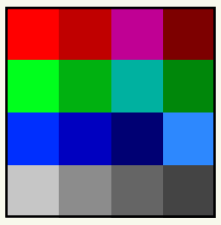

Create an image that looks something like picture shown at right in which

* row 1 - displays 4 different “reddish” colors (with red being the dominant color).
* row 2 - display should show 4 different “greenish” colors
* row 3 - should show 4 “bluish” colors
* row 4 - show only shades of gray

**Questions:**

1. Rewrite this string of numbers from raw format to readable format, and identify or label the sections of bits.

000000100000001000000011010010101010

1. How many more colors are available with 12 bits-per-pixel than 6 bits-per-pixel?
2. What happens if you have you an image that has 6 bits-per-pixel and you change it to 12?
3. A digital artist comes up to you and says, “Help! I need a 12-bit color that’s just a little bit greener than **#79B.”** What would you suggest and why?